ALL-PLATFORM COMPLAINT PACKAGE
CONFIDENTIAL | CLIENT FILES | INDEPENDENT

ATTORNEY 3 OF 3
MICHAEL ANTHONY TREVINO
Law Office of Michael A. Trevino PLLC
Priority 3 | "The Will Contest Guy" | FINAL

Complainant: Caroline Allison
Platforms Covered: FTC | Google | Yelp | Avvo | Texas AG | BBB
Research complete — all platforms verified — client files each independently
April 2026

EXECUTIVE SUMMARY

Michael Trevino brands himself 'The Will Contest Guy' — an Eagle Scout who follows the Golden Rule.
His last documented words to real client Gail Echols: 'Have you run out of money yet?'

He received a $600,000 arbitration award even though Richard Allison never signed a contract with him.

He previously worked at Radack & Borunda — Jorge Borunda's own former firm — explaining how three attorneys from the same professional network came to handle the Allison matter without disclosing their interconnection to clients.

His Google profile was fake-reviewed by Andrews Verdaux (alias tied to 2444 Times Blvd) and Nick Abaza (his co-attorney, six days after the Dolcefino investigation published).

His conduct contributed to approximately $20 million in total financial exposure to the Allison family.

SECTION 1 — PROFILES

Complainant: Caroline Allison
Full Name | Caroline Allison
Primary Email | ciakwm@gmail.com
Secondary Email | top500agent@gmail.com
Phone | 832-661-5001
Address | 3733-1 Westheimer Rd 1024, Houston TX 77027
Occupation | Realtor at Upside Homes LLC
Public Role | Founder, Stop Legal Bullying Now LLC
Bar Complaint | Existing Texas State Bar complaint currently on appeal
Legislative Action | Robin's Law, Attorney Accountability Act, Complaint Transparency Act, Arbitration Fairness Act
Co-Complainant | Richard Allison (brother) — rallson@hotmail.com — PO Box 81843, San Diego CA 92138
Avvo | Anonymous — 1 review successfully posted on each of Borunda, Abaza, and Trevino profiles
Google Case ID | 3-5713000040145 — filed April 3, 2026 — active
Dolcefino Part 1 | youtube.com/watch?v=j5aWUy6oJT0
Dolcefino Part 2 | youtu.be/lgHSGHJc7xE?si=ol_w95WdbGQUAmUd
Gail Testimonial | youtube.com/shorts/0vN_m_JAOQo

Subject: Michael Anthony Trevino
Full Name | Michael Anthony Trevino
Firm | Law Office of Michael A. Trevino, PLLC — founded 2020
Brand | willcontestguy.com — 'The Will Contest Guy'
State Bar | Licensed 2009 — 16 years of practice
Education | B.A. University of Texas at Austin — J.D. UNH Franklin Pierce School of Law 2008
CRITICAL CONNECTION | Previously worked at Radack & Borunda — THE SAME FIRM as Jorge Borunda
Prior Address | 1345 Campbell Rd Suite 220, Houston TX 77055 — same as Borunda's secondary listing
Broader Network | Seth Nichamoff — shares Abaza's office — participates in same contingency network — performed receivership against Allisons
Practice | Will contests — trust disputes — fiduciary litigation — 100+ cases — millions recovered
Fee Structure | Primarily contingency — you only pay if you recover
Awards | 2023 Super Lawyers Rising Stars — Estate and Trust Litigation
Avvo | Zero reviews — Not yet reviewed — 0.0 stars — despite 16 years of practice
Last Words to Gail | 'Have you run out of money yet?' — documented in Gail Echols' Avvo review
Arbitration Award | $600,000 awarded by Anne Ashby even though Richard Allison NEVER signed a contract with him
Investigation | Named in Dolcefino Media 'Damn Lawyers' Parts 1 and 2 — March 2026

Critical Finding — Trevino Worked at Radack & Borunda — Borunda's Former Firm
Source: Justia Lawyer Directory — Michael Trevino prior employment: Radack & Borunda
Source: Jorge Borunda's Justia profile — prior employment: Radack & Borunda, P.C.
Source: Michael P. Fleming & Associates (Trevino's other firm) — 1345 Campbell Rd Suite 220 — SAME ADDRESS as Borunda's secondary listing (permanently closed on Yelp 2026)

Trevino and Borunda came from the same firm. They shared the same secondary office address.
Clients who believe they have three independent attorneys are engaging a professionally interconnected network that was never disclosed to them at engagement.
This is the origin of every cross-review and cross-referral documented in this case.

SECTION 2 — CASE BACKGROUND AND FINANCIAL LOSSES

The Case That Started Everything
"We didn't realize until much later that their interests had nothing to do with our well-being, and everything to do with how much money they could take from my dad's trust."
— Caroline Allison — GlobeNewswire press release — March 17, 2026

Case Background — Dr. Richard Gerard Allison Estate — Documented Facts
Matter: Estate of Dr. Richard Gerard Allison — father of Caroline and Richard Allison
Estate value: Approximately $20 million — real estate, investments, liquid and illiquid assets
Father: Physician and investor — admirer of Warren Buffett — died after long battle with dementia
Problem: Stepmother not cooperating with estate — family sought legal representation

THE FEE SWITCH (Borunda's doing):
Caroline started at $475/hr — spent approximately $70,000 through discovery.
Between mediations, Borunda convinced her to switch to 35% contingency fee.
This converted a $10,000 legal debt into a $1.4 million payday claim for the attorneys.

THE SETTLEMENT:
Per independent expert report (Dolcefino Media, March 2026): attorneys gave up approximately $15 million in other assets in an early-morning mediated settlement.
Richard Allison: 'They just basically created a big mess.'
Caroline Allison: 'We gave up more than we got.'

THE ARBITRATION TRAP:
Borunda invoked hidden mandatory arbitration clause — on record: 'We are going to invoke the arbitration agreement.'
Stripped Caroline and Richard of their Seventh Amendment right to a jury trial – “invoked arbitration clause”
Arbitrator Anne Ashby (Dallas) had undisclosed conflicts — ruled for attorneys.
Ashby awarded $600,000 to Trevino even though Richard NEVER signed a contract with him.
Appeal pending at the Texas Supreme Court.

Documented Financial Losses — Caroline and Richard Allison
TOTAL FINANCIAL EXPOSURE: approximately $20,000,000

Inheritance forfeiture: $15,000,000
Arbitration fee award to attorneys: $4,000,000 (Anne Ashby — under appeal)
— includes $600,000 to Trevino specifically despite Richard never signing a contract with him
Ongoing legal fees (active pursuit): $1,500,000+

Exhibit 1: youtube.com/watch?v=j5aWUy6oJT0
Exhibit 2: youtu.be/lgHSGHJc7xE
Exhibit 5: finance.yahoo.com/economy/policy/articles/consumer-alert-mandatory-arbitration-enables-230400790.html

SECTION 3 — FAKE REVIEWS AND CONDUCT

Exhibit A — Nick Abaza 5-Star on Trevino Google — Own Name — During Investigation
Reviewer: nick abaza — own real name — March 30, 2026 — labeled New
Platform: Law Office of Michael A. Trevino Google Business Profile
March 17, 2026: Dolcefino investigation published naming Abaza and Trevino (Exhibits 1 and 4)
March 30, 2026: Abaza posts 5-star — 6 days later — under own real name
Abaza is not Trevino's client — he is his co-party in an active investigation
FTC Violation: Non-client review misrepresented as independent endorsement

── EXHIBIT A ──
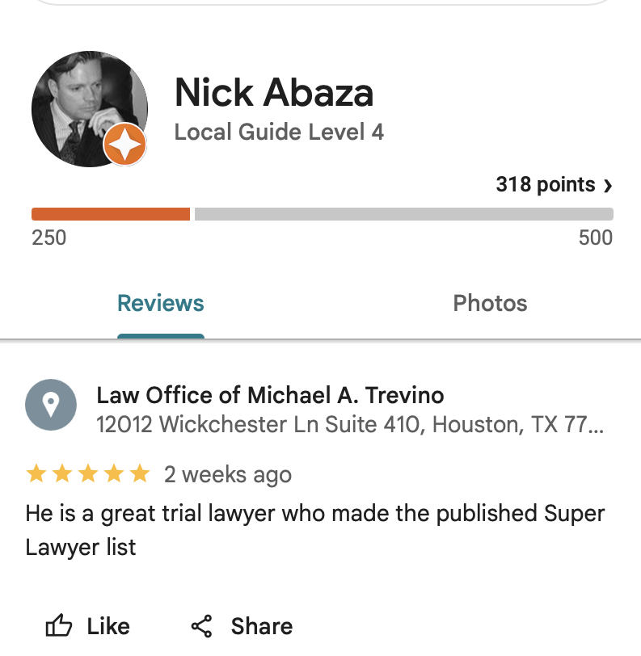

Exhibit B — Jamie Reneau suspiciously writes a new review for Michael Trevino on 4-14-2026; and is part of the new Abaza review flood

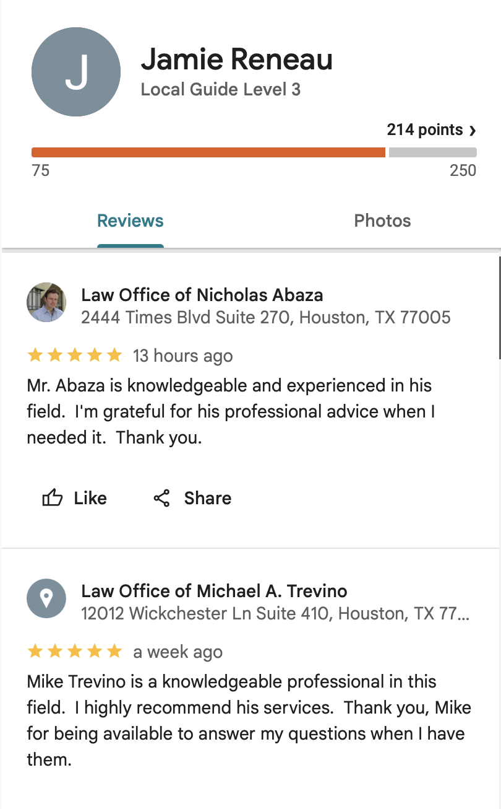

Exhibit C — Caroline’s real client review ghosted on Trevino’s google business listing

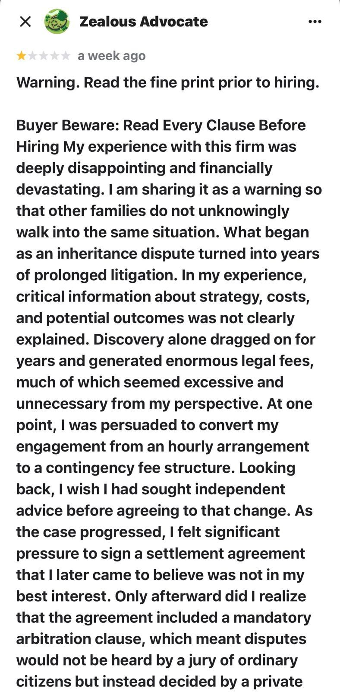
[Zealous Advocate on Trevino — 1 of 3] Avvo — ‘Zealous Advocate’ — 1 star — title: ‘Warning. Read the fine print prior to hiring.’ — review begins discussing Trevino engagement (text cut off — continues in next screenshot) GHOSTED
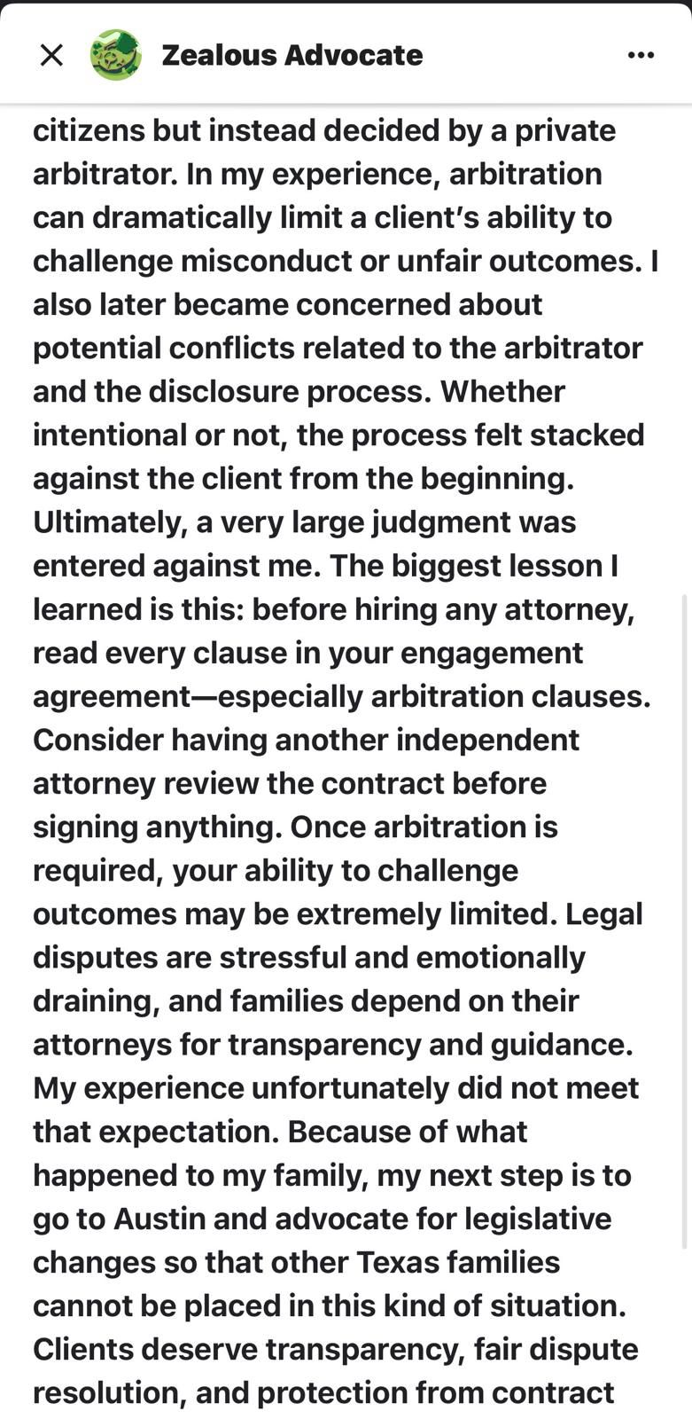
[Zealous Advocate on Trevino — 2 of 3] continuation — arbitration clause, malpractice insurance, arbitrator conflicts, process felt stacked against client (text cut off — continues in next screenshot) - GHOSTED
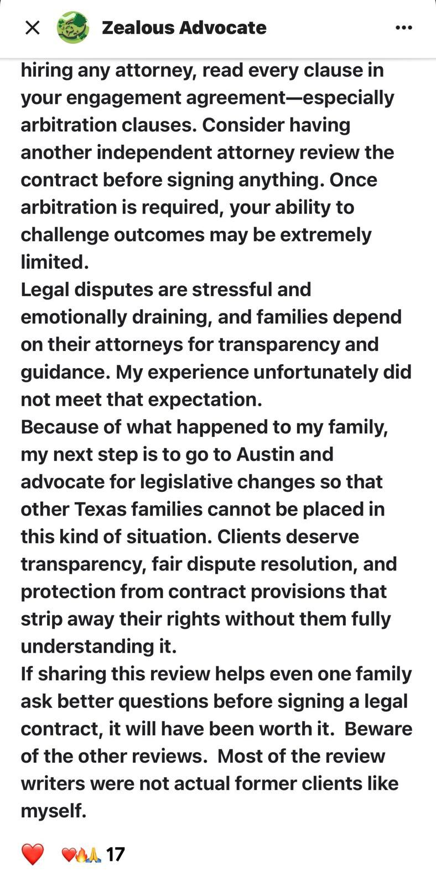
[Zealous Advocate on Trevino — 3 of 3] final portion — ends: ‘I am writing a review as a real client.’ — 7 likes - GHOSTED

Exhibit D — Andrews Verdaux Alias on Trevino Google + Radack & Borunda Connection
Account: andrews verdaux | 18 reviews | 225 Google Maps points
Date: Approximately March 29, 2026 — labeled New
Andrews Verdaux review was deleted after Caroline called out their fake reviews.
Review: 'He is a great trial lawyer. He expert in Will contests and Estate Litigation.'
KEY: This account also reviewed 'Law Office of Nicholas Abaza — 2444 Times Blvd Suite 270' — shared address of Borunda and Abaza — Trevino's former colleagues
Former client publicly identified this as a fake alias — Google review March 22, 2026
FTC Violation: Fake review under alias connected to attorney network's office address

── EXHIBIT D ──
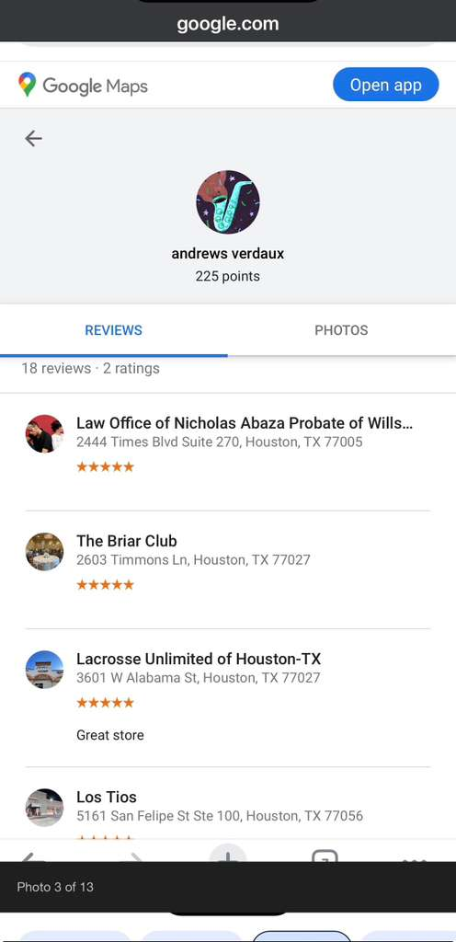

Exhibit E — Justia review blocked. Trevino required the client to not post anonymously as per these messages.

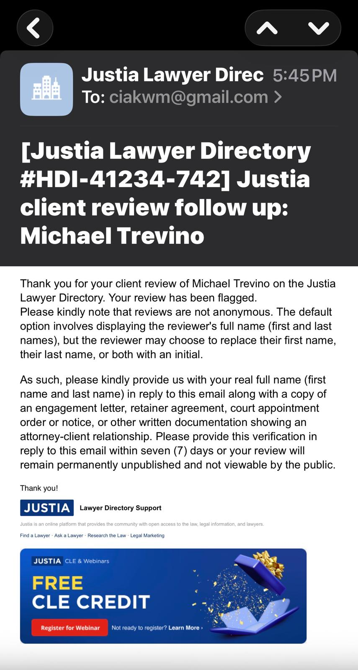
Justia Lawyer Directory — Michael Trevino attorney profile — Radack & Borunda employment shown — contact information
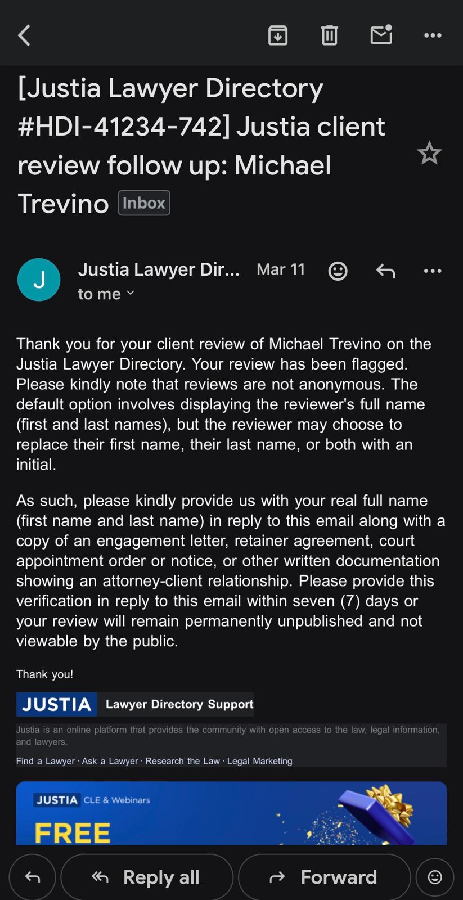
Justia — Michael Trevino — client review follow-up email — case review reference #HDI-41234-742 — prior employment at Radack & Borunda visible — 1345 Campbell Rd address shown

Exhibit F — $600,000 Awarded Without a Signed Contract — Arbitration
Anne Ashby awarded $600,000 to Michael Trevino in the malpractice arbitration.
Richard Allison NEVER signed a contract retaining Michael Trevino.

"How did this happen? The only conclusion you could reach is that it was rigged."
— Caroline Allison

"She wrote in her judgment saying that I had zero credibility."
— Richard Allison

Ashby had undisclosed conflicts and failed to disclose a Chapter 7 bankruptcy.
Ruling under appeal at Texas Supreme Court.
Trevino is now actively pursuing collection of this award — contributing to the $1.5M+ in ongoing legal fees the Allisons are facing.

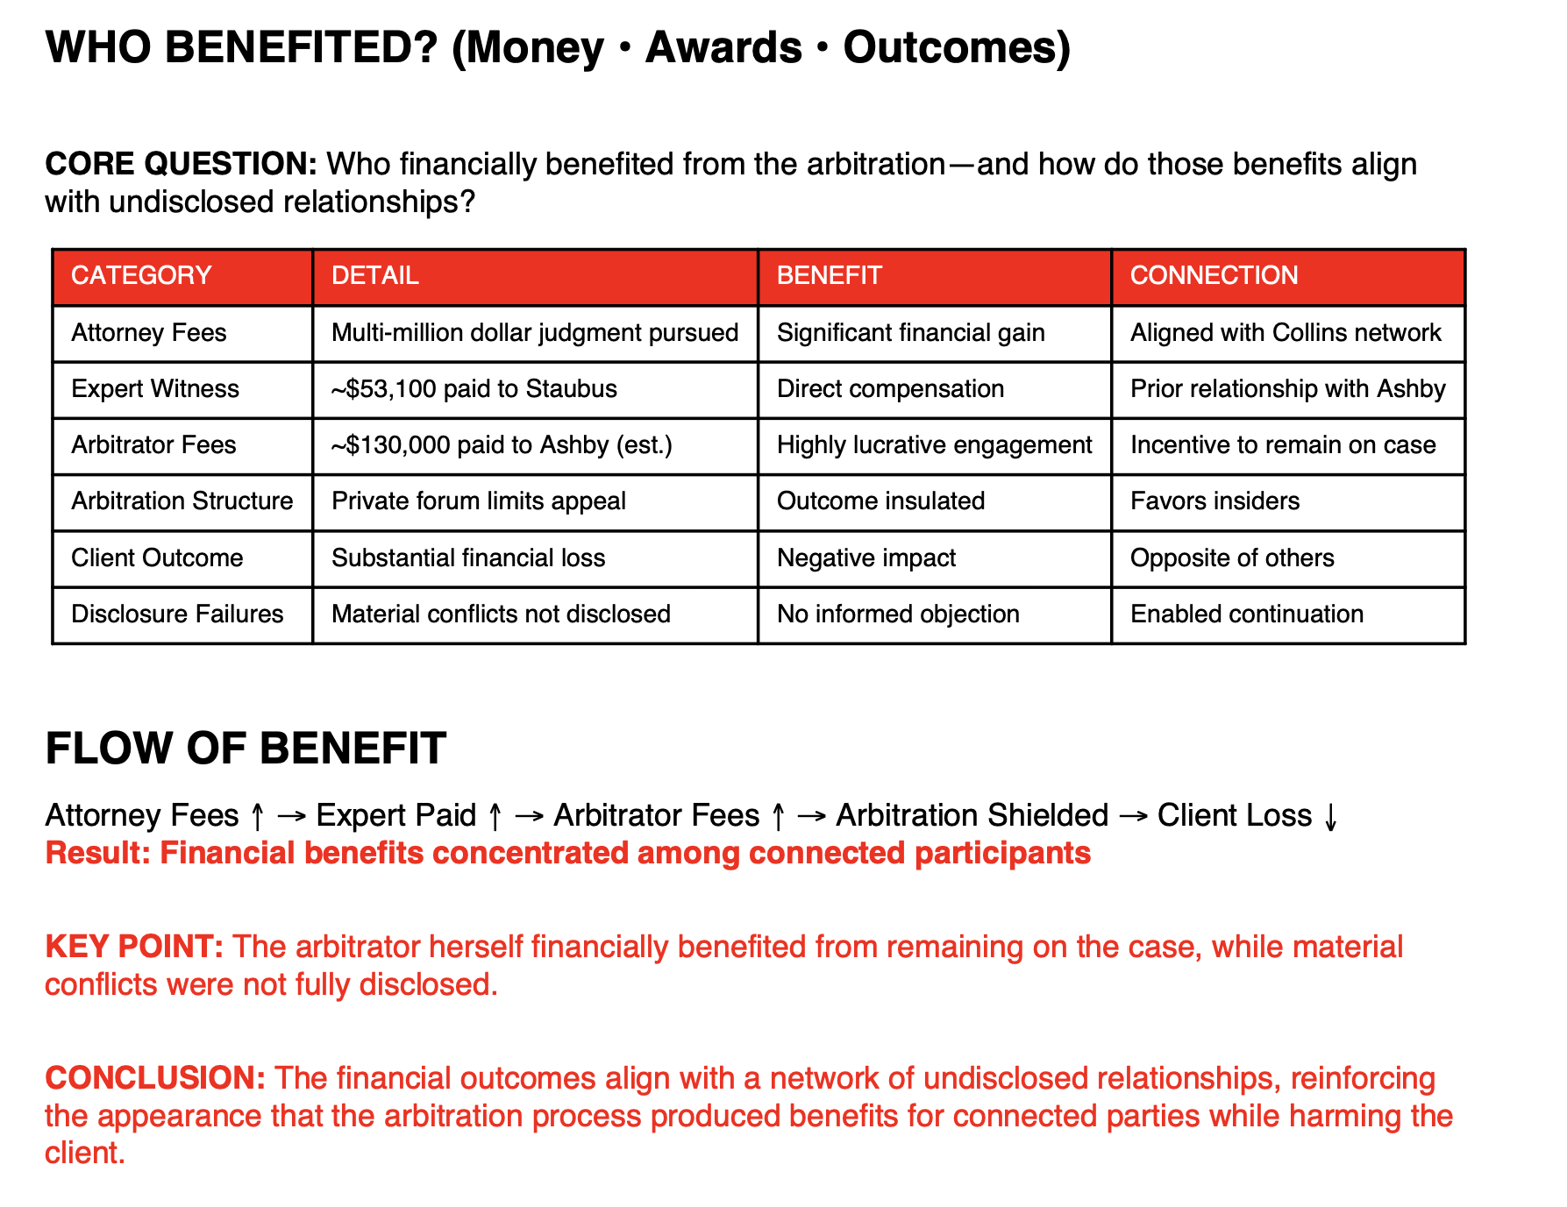

Exhibit G — Caroline’s Avvo review of Michael Trevino – finally posted after multiple attempts

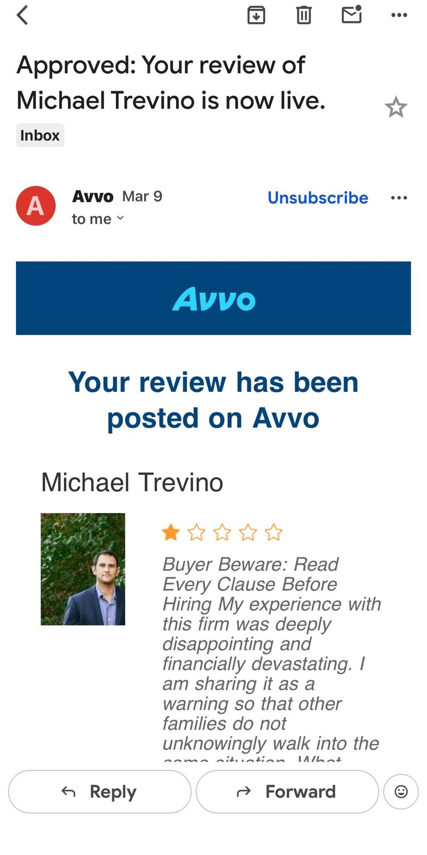
Avvo email — ‘Approved: Your review of Michael Trevino has been posted on Avvo’ — review confirmed live
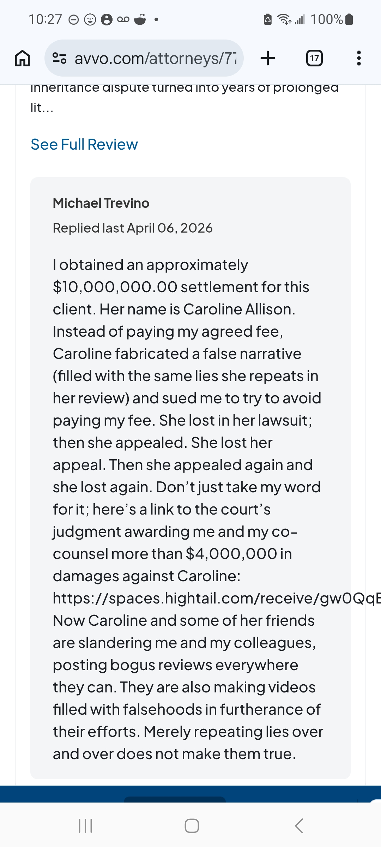
Avvo — Michael Trevino — attorney owner response to client review — response names Caroline Allison by full name and describes litigation history — posted April 6, 2026

Exhibit H — Trevino Avvo — Zero Reviews — 16 Years of Practice
Avvo: Not yet reviewed — 0.0 stars — zero client reviews
Licensed 2009 — 16 years — markets 100+ cases and millions recovered
2023 Super Lawyers Rising Stars designation
Zero reviews across all platforms for a self-described major trial specialist
Consistent with the suppression pattern across all three attorneys in this network

Exhibit I — Fellow friend Bryan Westbrook, another lawyer poses as a client on Trevino’s Google Business listing
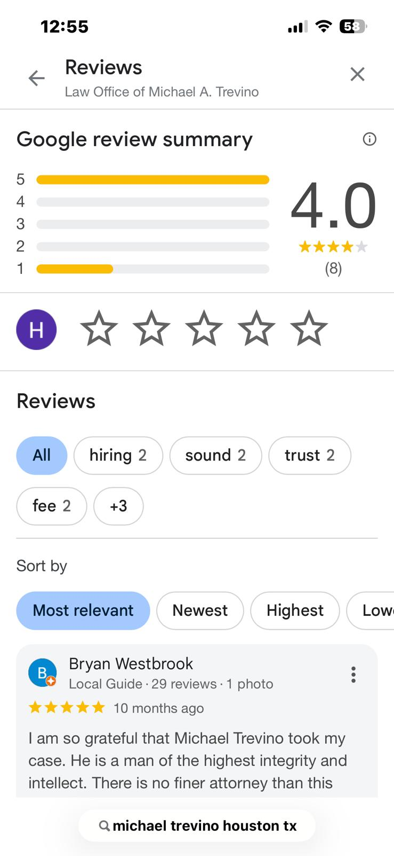
Google business listing — restricted/limited reviewer profile

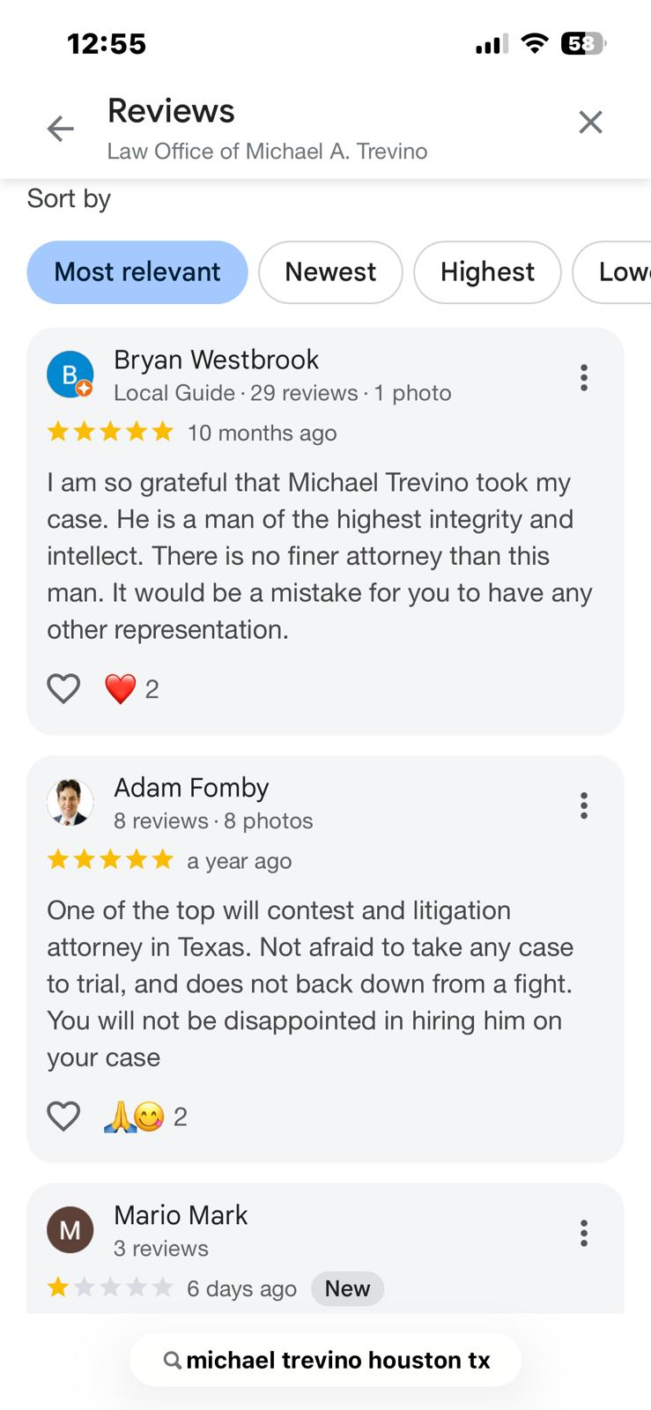
Trevino Google reviews — By Most relevant
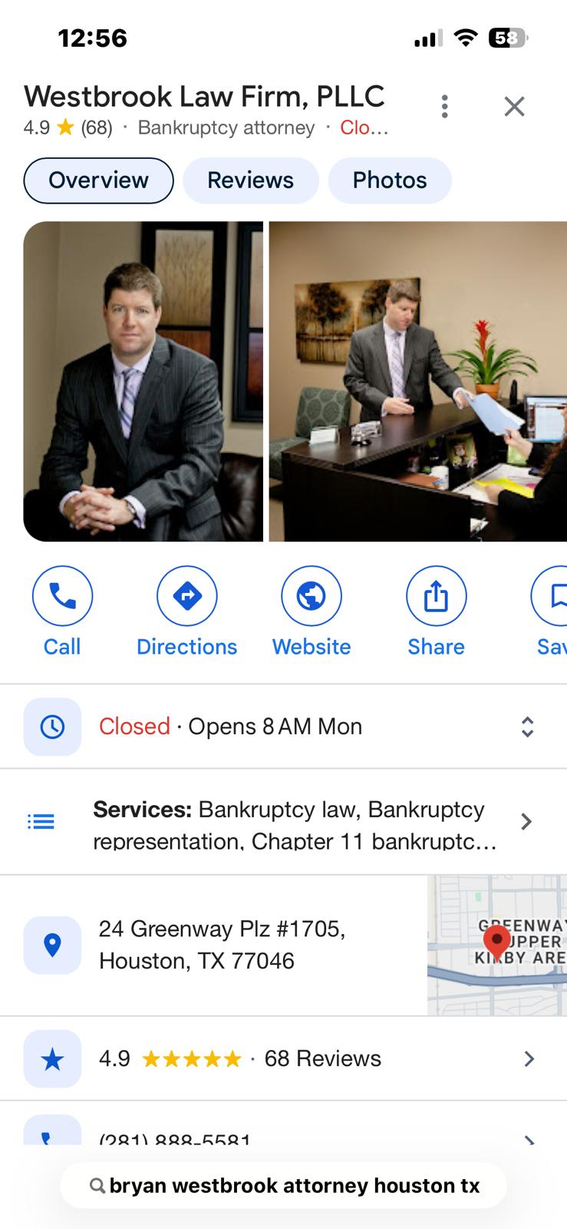
Bryan Westbrook is an attorney writing a review for Michael Trevino – posing as a client – “I am so grateful Michael Trevino took my case”. He’s a bankruptcy attorney.

Exhibit J — Nick Abaza 5-Star on Trevino Google — Own Name — During Investigation
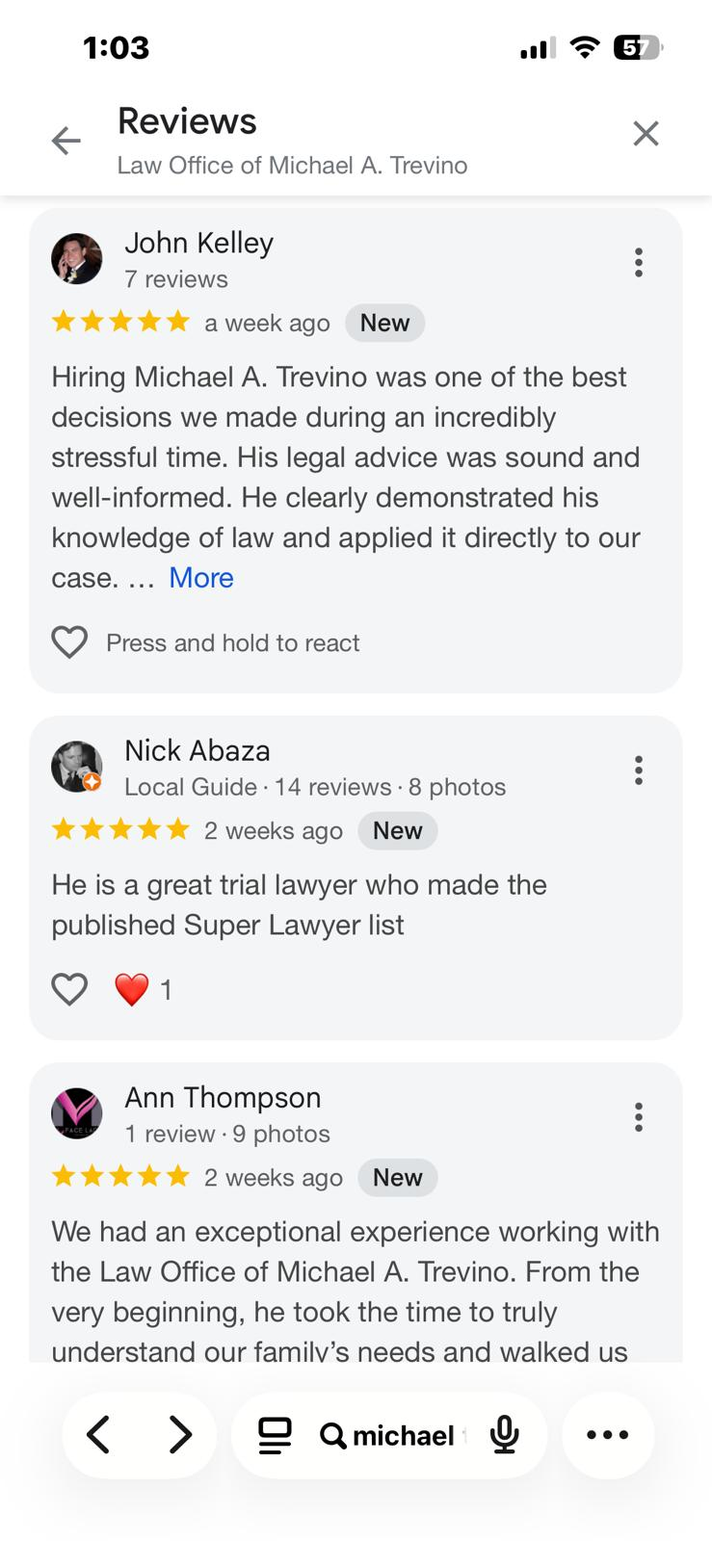
Google — Nicholas Abaza 5-star review for Michael Trevino — posted March 30, 2026 — Abaza is shown as reviewer on Trevino’s Google profile

Exhibit K — Nick Abaza 5-Star on business partner Jorge Borunda – Borunda & Fomby

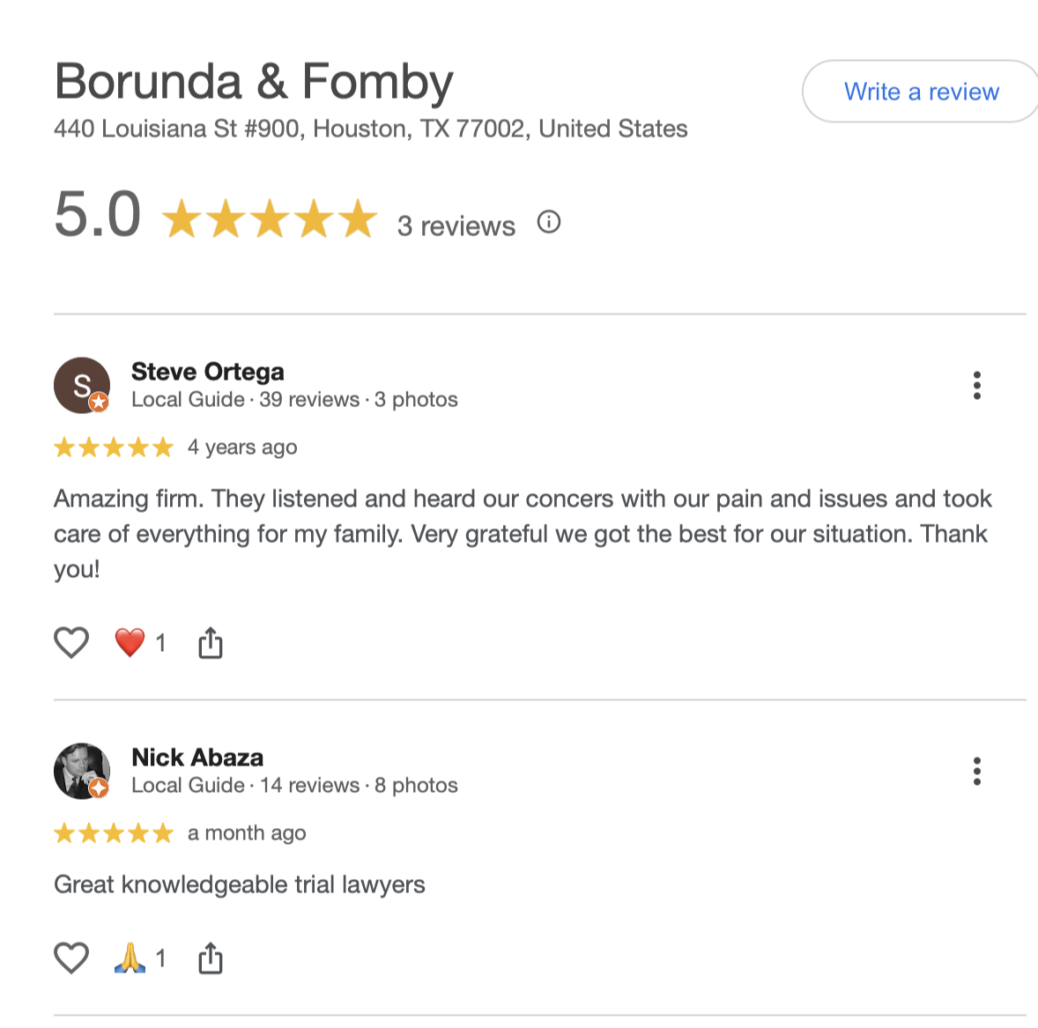

UNPROMPTED AND REPEATED POSTS INTENDED TO DEFAME FORMER CLIENTS ON GOOGLE, AVVO, AND REDDIT – USING PRIVILEGED INFORMATION
Identity: Nick Abaza, Jorge Borunda, and Michael Trevino

FORMER CLIENT POSTED PUBLIC REVIEWS AS A FORMER CLIENT WITH THE INTENT TO REMAIN ANONYMOUS

PATTERN OF CONDUCT:
Nick Abaza, Jorge Borunda, and Michael Trevino have all 3 responded to client reviews discussing real client experiences, where the client posted under a screen name, and merely posted about her personal experience and the results she got working with the attorneys. She was careful to talk about her personal experience and avoid defamatory remarks.
These 3 attorneys have all responded, naming the client specifically, and posting a link to the lawsuit, where they proclaimed victory against the client who was expressing their grievance in a public review.
The attorneys did not merely respond to criticism—they each weaponized confidential client information in a public forum, identifying a former client who attempted to remain anonymous, disclosing sensitive case details, and making accusatory statements that go far beyond any permissible self-defense under the Texas Disciplinary Rules of Professional Conduct. This wasn’t a defense—it was a public exposure of a client using privileged information.

FTC AND STATE BAR RELEVANCE:

At a high level, this can be characterized as:
- Breach of client confidentiality
- Improper public self-defense
- Client intimidation / retaliation
- Prejudicial public statements about a client
- Possible defamation (depending on truthfulness)
- Misleading Statements
- Harrassment

1. Rule 1.05 — Confidentiality of Information
This is the biggest issue. A lawyer shall not knowingly reveal confidential information of a client.
Reasons for why this violates Rule 1.05: He publicly identified you by name (when you tried to remain anonymous), referenced your settlement amount ($10M), discussed the fee dispute and litigation history that information arose from the representation. Even if some of it is in public records, lawyers are still restricted from voluntarily broadcasting it. This is not allowed in a public social media rebuttal.

2. Rule 1.06 — Conflict of Interest (Self-Interest)
When a lawyer’s personal interest (fees, reputation) conflicts with the client’s interest: posting publicly to protect reputation or collect fees, while harming a former client that’s a self-interest conflict in action

3. Rule 8.04 — Misconduct

(a)(3): Conduct involving dishonesty, fraud, deceit, or misrepresentation

(a)(7): Conduct that adversely reflects on fitness to practice law
Potential issues:
- Calling your review “fabricated” and “false”
- Framing you as acting in bad faith
- Publicly attacking a former client
👉 If exaggerated or misleading → misrepresentation
👉 Even if partially true → still improper if disclosed improperly

4. Rule 3.07 / 3.04 — Trial Publicity & Conduct Prejudicial to Justice
- Publicly litigating disputes online
- Posting links to judgments to influence perception
- Attempting to shape narrative outside court
5. Rule 8.04(a)(3) – Misrepresentation
Defamed the Client when he says, “Caroline fabricated a false narrative…”
This is dangerous for the attorney because it is a direct accusation of dishonesty. If not provably true, this opens the attorney to defamation exposure. Even if arguable, it still problematic under ethics rules when said publicly about a former client
6. Rule 7.02– Misleading Statements

He falsely claimed he obtained a $10,000,000 settlement and mischaracterized the outcome. The funds stayed in a trust and were never distributed.

7. Rule 8.04 – Harrassment

Respondent engaged in repeated public attacks against me across multiple platforms.

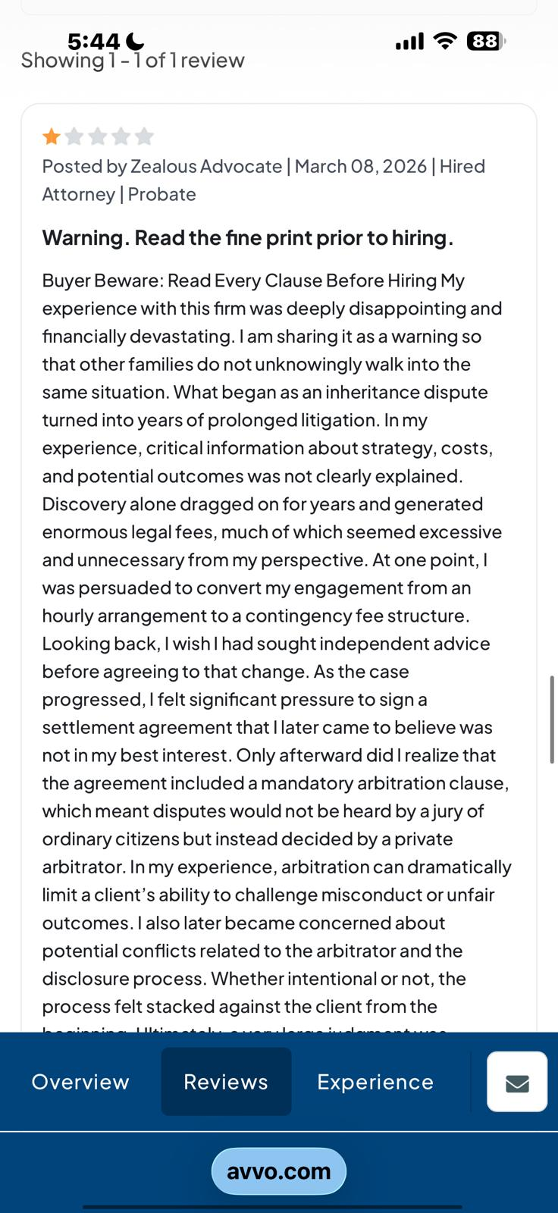

Avvo — Caroline Allison posted a review anonymously and Trevino responds
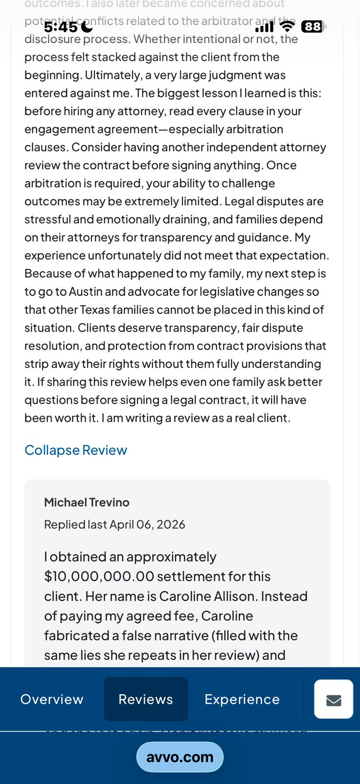

Avvo — Caroline Allison posted a review anonymously and Trevino responds

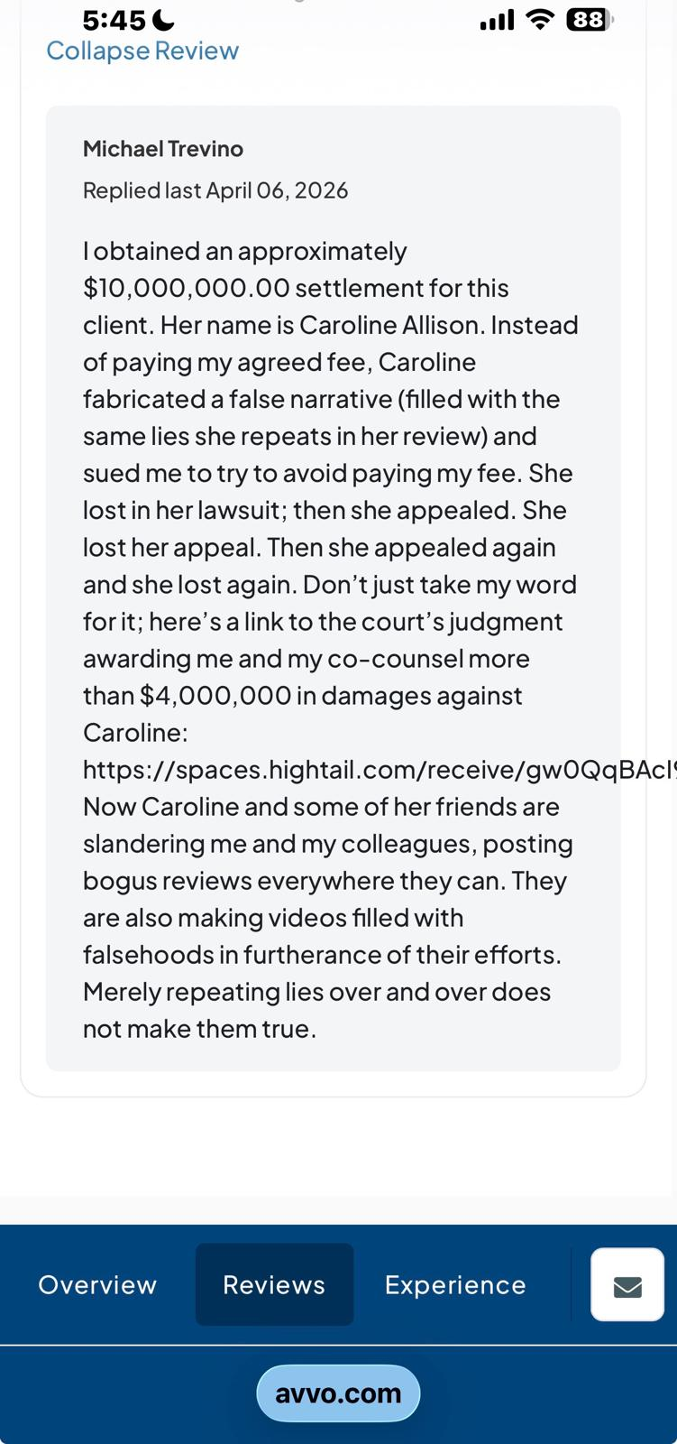

Avvo — Caroline Allison posted a review anonymously and Trevino responds

SECTION 3A — REVIEW SUPPRESSION CONFIRMED: CLIENT REVIEW REPOSTED UNDER 'HOUSTON ASTROS FAN'

Background: 'Property Management' Review Ghosted — Platform Forced New Account
CLIENT STATEMENT (as recorded):
"Trevino, my other review under Property Management was ghosted. So I had to remove and replace under another profile Houston Astros Fan."
Context: The client's "Property Management" account review of Michael Trevino was ghosted (hidden/suppressed) by the platform. The client was forced to remove that review and repost using an alternate account, "Houston Astros Fan," in order to maintain a factual review record of Trevino's conduct. The content and authorship are attributed solely to this client and to Michael Trevino's profile.

"Property Management" Account — Original Ghosted Review (Still Visible on Profile)
The original "Property Management" review of Trevino remains visible on his Google profile and contains the following documented statement:

"In my personal experience, Mr. Trevino is a zealous advocate for his wallet, and he gives advice accordingly. I've also witnessed both Mr. Trevino and his colleagues Jorge Borunda and Nick Abaza actively work to delete my reviews as a [former client]..."

— Property Management — Local Guide, 16 reviews — Google — Michael A. Trevino profile

This review documents the client's firsthand observation of Trevino actively working to delete real client reviews — which is directly confirmed by the subsequent ghosting of this same account's review and the forced repost under "Houston Astros Fan."

New Review Posted Under 'Houston Astros Fan' — Trevino Profile
Platform: Google Reviews — Law Office of Michael A. Trevino (3.4 stars, 10 reviews)
Reviewer account: Houston Astros Fan — 2 reviews, 9 photos
Rating: 1 star — posted 16 minutes ago (as captured in screenshot)

FULL REVIEW TEXT (as posted — attributed to Michael Trevino):
"It was simply the worst mistake I've made in my entire life. My prior review was removed by Mr. Trevino without my authorization or consent. Just because he decided to strip me of my 7th amendment constitutional right to a fair trial. My 1st amendment constitutional right to freedom of expression allows me to write at least my one review outlining my personal experience of hiring Mr. Trevino and his business partners and friends — Mr. Abaza and Mr. Borunda.

Mr. Trevino continues to attack me as a former client rather than addressing a client grievance and/or dissatisfaction with his legal services. The fact of the matter is that he misled me into agreeing to forfeit a huge part of my inheritance for the sole purpose of him garnering a legal fee based on false information. Then he sued for a legal fee based on breach of contract because he so badly wanted a fee for performing poorly.

Every client signs a contract with an arbitration clause. Plus they do not carry legal malpractice insurance. If they mess up your case, you will never be able to hold them accountable.

Furthermore, here's a copy of the arbitrator oath. They rigged the arbitration. So saying they won is like saying that cheating and getting an "A" means you get to keep the "A".

I was merely highlighting his fake reviews and fake profiles he creates to bolster his star rating. I fell into that trap when I hired him. There are a few of us former clients who had to sue them. A client only takes legal action on their attorney if there was significant financial loss that outweighs the effort and cost of pursuing such claims.

These lawyers hide behind the arbitration clause and the fact they have no insurance. In addition, they did not disclose underlying conflicts in their choice of arbitrator. Cheating on the arbitration does not mean they "won". It means they "cheated."

We are well aware of the compromised, conflicted arbitrator despite their claims of successful legal actions. Their high conflict litigation funnel into their multiple websites recommending undoing and blowing up family legacies is just a sad statement about their business practices. In my personal experience, not only was my inheritance destroyed, but my family was completely destroyed thanks to their bad advice."

Note on account name: The client's normal "Property Management" screen name was ghosted/suppressed following a prior review of Trevino. The alternate account "Houston Astros Fan" was used solely to preserve the client's factual review record of Michael Trevino. The review is properly attributed to this client and relates exclusively to Michael Trevino and his professional network.

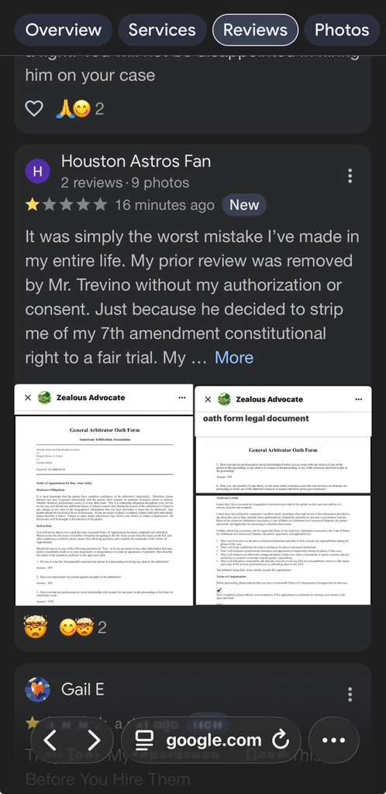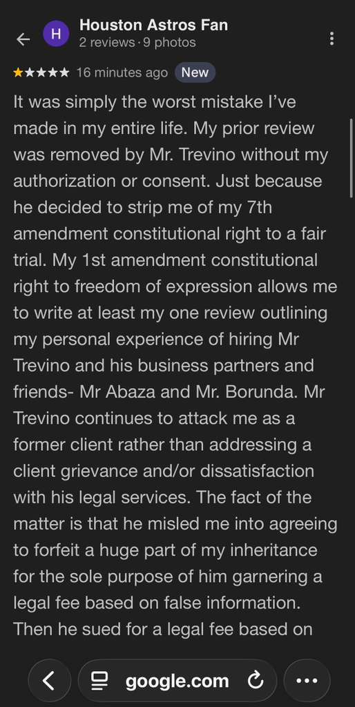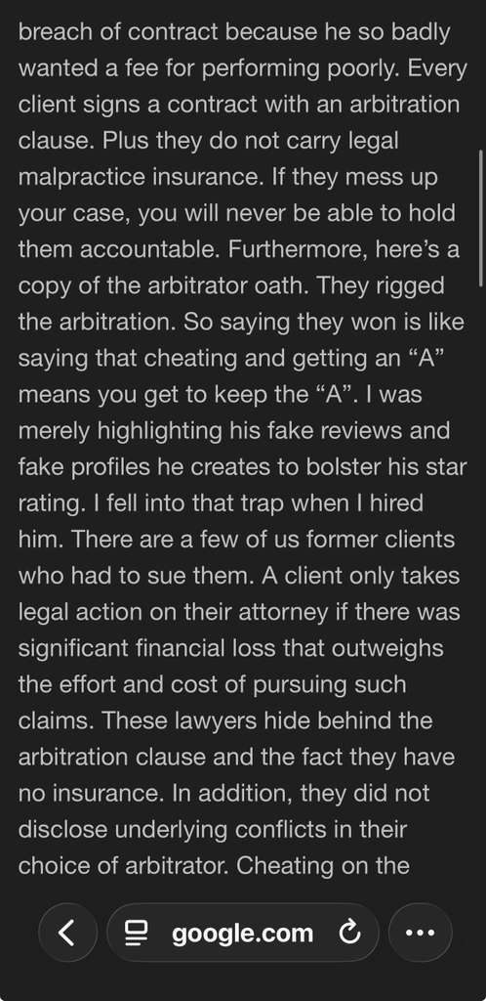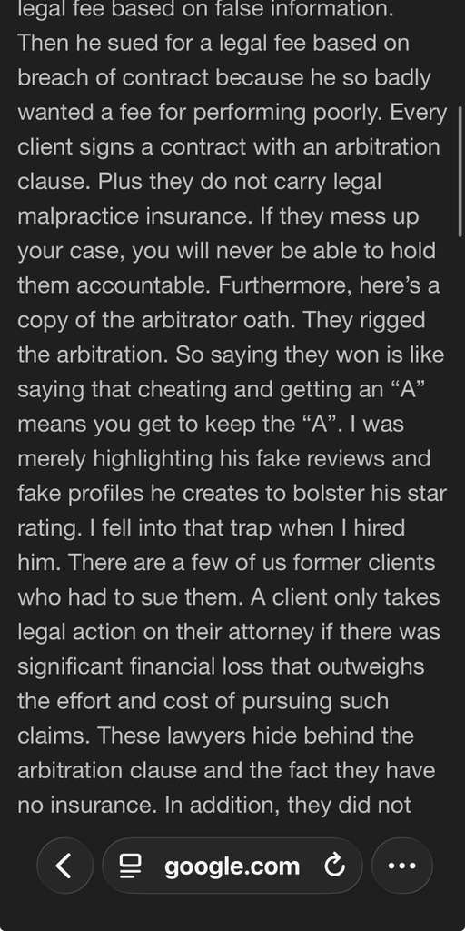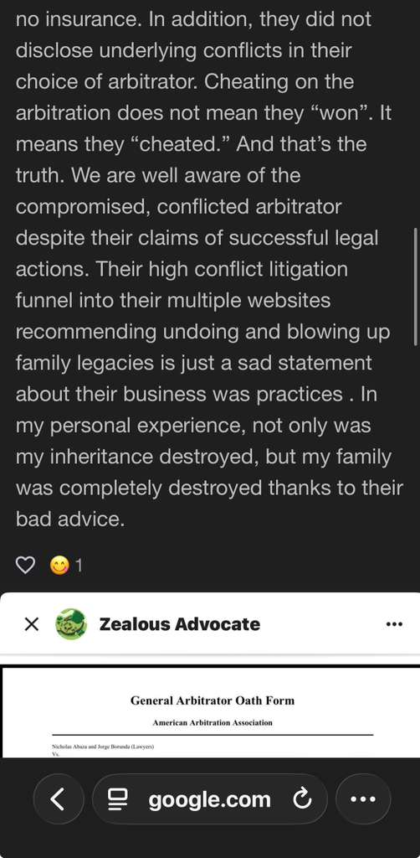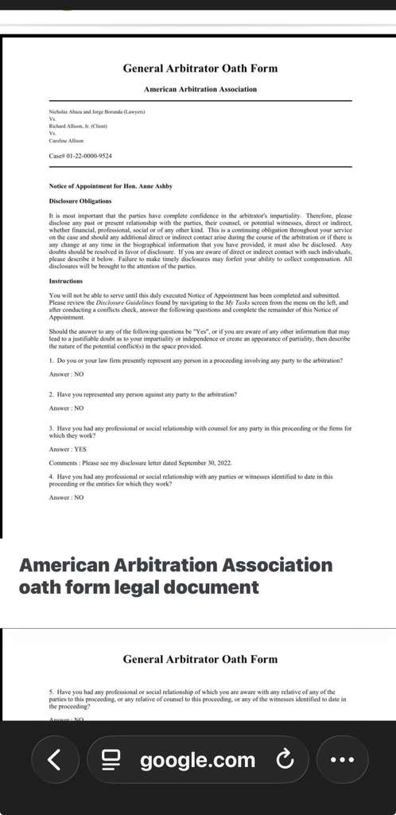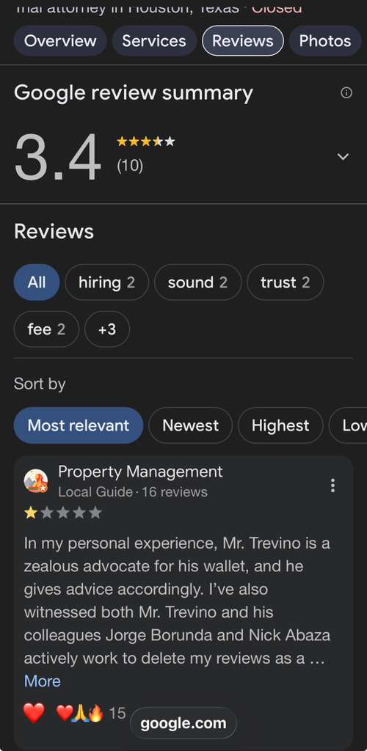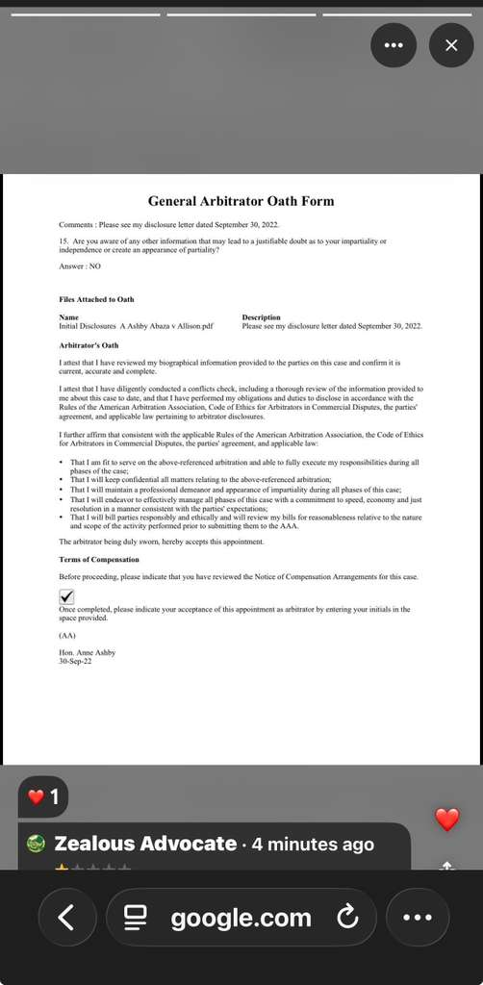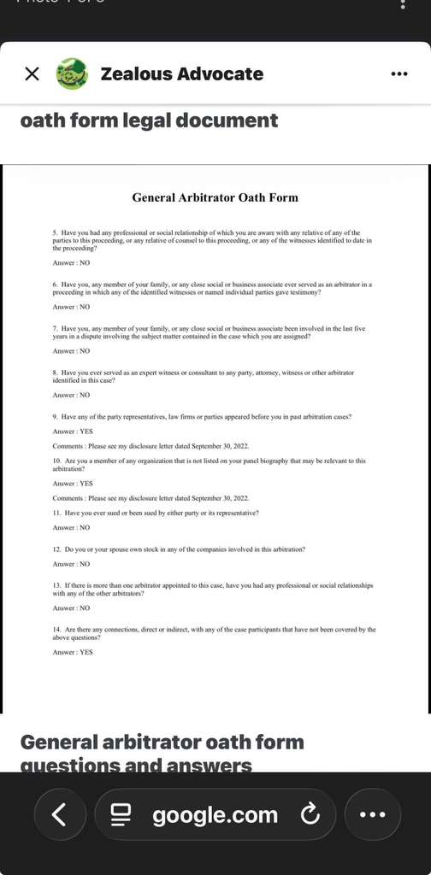

SECTION 3B — ARBITRATOR OATH FORM — UNDISCLOSED CONFLICTS — ANNE ASHBY

Oath Form — Case 03-22-0000-9524 — American Arbitration Association
The arbitrator oath form for Hon. Anne Ashby in Case 03-22-0000-9524 (Nicholas Abaza and Jorge Borunda v. Richard Allison / C. Allison — American Arbitration Association) reveals critical undisclosed conflicts.

CRITICAL FINDINGS FROM THE OATH FORM:

Question 3: Have you had any professional or social relationship with counsel for any party in this proceeding or the firms for which they work?
Answer: YES — "Please see my disclosure letter dated September 30, 2022"

Question 9: Have any of the party representatives, law firms, or parties appeared before you in past arbitration cases?
Answer: YES — "Please see my disclosure letter dated September 30, 2022"

Question 10: Are you a member of any organization not listed on your panel biography that may be relevant to this arbitration?
Answer: YES — "Please see my disclosure letter dated September 30, 2022"

Question 14: Are there any connections, direct or indirect, with any of the case participants not covered by the above questions?
Answer: YES

FOUR affirmative disclosures — all deferred to a disclosure letter dated September 30, 2022 — the adequacy and completeness of which is disputed and is the subject of the pending Texas Supreme Court appeal.

Significance — Why This Matters for the Trevino Award
Anne Ashby's affirmative answer to Question 3 (professional/social relationship with counsel) is particularly significant because Trevino was one of the attorneys appearing before her. She had a prior professional or social relationship with at least one party's counsel on the underlying probate case— and concealed making minimal disclosures 8.5 months after appointment and timed it for when everyone was busy with trial preparation. Ashby was required to read up on the case prior to appointment and disclose all conflicts upfront. Had she disclosed her conflicts, she never would have gotten the job.
She awarded $600,000 to Michael Trevino — an attorney who never had a signed contract with Richard Allison — despite this undisclosed conflict.
Richard Allison: 'She wrote in her judgment saying that I had zero credibility.' This characterization, combined with the multiple YES answers on the oath form, forms the basis of the Allisons' claim that the arbitration was compromised.

Questions and Answers — Full Reproduction from Oath Form:
Case: 03-22-0000-9524 — American Arbitration Association
Arbitrator: Hon. Anne Ashby — appointed September 30, 2022
Parties: Nicholas Abaza and Jorge Borunda (attorneys) / Richard Allison, C. Allison

Q1: Do you or your law firm presently represent any person in a proceeding involving any party? Answer: NO
Q2: Have you represented any person against any party to the arbitration? Answer: NO
Q3: Professional or social relationship with counsel for any party or their firms? Answer: YES — see disclosure letter 9/30/2022
Q4: Professional or social relationship with parties or witnesses? Answer: NO
Q5: Professional or social relationship with any relative of parties, counsel, or witnesses? Answer: NO
Q6: Family member or associate served as arbitrator where identified witnesses testified? Answer: NO
Q7: Involved in last 5 years in dispute involving subject matter of this case? Answer: NO
Q8: Served as expert witness or consultant to any party, attorney, or witness in this case? Answer: NO
Q9: Have party representatives, law firms, or parties appeared before you in past arbitration? Answer: YES — see disclosure letter 9/30/2022
Q10: Member of organization not on biography that may be relevant? Answer: YES — see disclosure letter 9/30/2022
Q11: Have you ever sued or been sued by either party or representative? Answer: NO
Q12: Do you or spouse own stock in any company involved? Answer: NO
Q13: Professional or social relationships with other arbitrators on this case? Answer: NO
Q14: Any other connections, direct or indirect, with case participants? Answer: YES
Q15: Any other information leading to justifiable doubt as to impartiality? Answer: NO

SECTION 4 — FULL TIMELINE
Date | Event | Evidence
2016 | Prior lawsuit — same three attorneys — nearly identical allegations — settled out of court | Dolcefino citation
2009 | Trevino licensed — begins practice | State Bar ID
Pre-2020 | Trevino works at Radack & Borunda — Borunda's former firm — operates from 1345 Campbell Rd Suite 220 | Justia profile / Exhibit B
2020 | Trevino founds Law Office of Michael A. Trevino PLLC — brands as willcontestguy.com | Firm records
Post-2019 | Caroline retained Borunda $475/hr — spent $70K through discovery | Documented
Mid-engagement | Borunda switches to 35% contingency — $10K debt to $1.4M payday claim | Fee switch
9/30/2022 | Anne Ashby appointed as arbitrator — oath form signed — 4 YES answers — conflicts deferred to disclosure letter | Exhibit F
Early 2026 | $15M in assets given up in early-morning settlement — per expert report | Dolcefino Media
Early 2026 | Arbitration conducted — Ashby awards $600,000 to Trevino — Richard never signed contract with him | Arbitration award
3/17/2026 | Dolcefino Part 1 published naming Trevino, Abaza, and Borunda | Exhibits 1, 4
3/22/2026 | Former client publicly identifies "andrews verdaux" as fake alias on Google | Exhibit B
3/24/2026 | Dolcefino Part 2 published | Exhibits 2, 5
3/29/2026 | "andrews verdaux" posts 5-star review on Trevino Google — labeled New | Exhibit B
3/30/2026 | Nick Abaza posts 5-star review on Trevino Google under own name — 6 days after investigation | Exhibit A
4/3/2026 | Google complaint filed — Case ID 3-5713000040145 | Active
4/4/2026 | Gail Echols submits Avvo review of Trevino — pending — includes "Have you run out of money yet?" | Exhibit E
4/6/2026 | Trevino posts owner response on Avvo naming Caroline Allison by full name | Exhibit C
Post-4/6/2026 | "Property Management" review of Trevino ghosted by platform — client forced to repost under "Houston Astros Fan" account | Exhibit E-1, E-2
Active | Trevino pursuing collection of $600,000 arbitration award — Texas Supreme Court appeal pending | Ongoing

SECTION 5 — PLATFORM COMPLAINT GUIDE

Platform 1: Federal Trade Commission — reportfraud.ftc.gov
- Go to reportfraud.ftc.gov — click Report Now
- Select: Something Else — Deceptive or Unfair Business Practices
- Business: Law Office of Michael A. Trevino PLLC — willcontestguy.com — Houston TX 77055
- Paste narrative below — submit — save reference number

TO: Federal Trade Commission — reportfraud.ftc.gov
COMPLAINANT: Caroline Allison — ciakwm@gmail.com — Houston TX
ATTORNEY: Michael Trevino / Law Office of Michael A. Trevino PLLC — willcontestguy.com
DATE: April 2026

I am Caroline Allison, Founder of Stop Legal Bullying Now LLC.

FINANCIAL IMPACT: Trevino's conduct as part of the three-attorney team contributed to approximately $20 million in total financial exposure. He was awarded $600,000 in arbitration by a conflicted arbitrator even though my brother Richard never signed a contract retaining him. That award is under appeal at the Texas Supreme Court.

CRITICAL UNDISCLOSED CONNECTION:
Trevino previously worked at Radack & Borunda — Jorge Borunda's former law firm. He also operated from 1345 Campbell Rd Suite 220 — Borunda's secondary address. Three attorneys presented as independent were in reality an interconnected professional network — never disclosed to clients at engagement.

VIOLATION 1 — CO-ATTORNEY CROSS-REVIEW DURING INVESTIGATION (Exhibit A):
Nicholas Abaza posted a 5-star review on Trevino's Google under his own name on March 30, 2026 — 6 days after Dolcefino published an investigation naming both. Abaza is not Trevino's client. FTC Rule: Non-client review as false endorsement.

VIOLATION 2 — ALIAS TIED TO SHARED OFFICE ADDRESS (Exhibit B):
Google account andrews verdaux (18 reviews) posted 5-star on Trevino's profile. Same account reviewed Abaza at 2444 Times Blvd Suite 270 — Borunda and Abaza's shared address — Trevino's former colleagues from Radack & Borunda. Identified as fake alias by former client March 22, 2026.

REVIEW SUPPRESSION EVIDENCE:
Client's "Property Management" Google review of Trevino was ghosted by the platform, forcing the client to repost the same factual account under a new account ("Houston Astros Fan"). The pattern of ghosting real client reviews while fake reviews from professional colleagues are sustained is itself evidence of suppression.

BACKGROUND: Trevino's last documented words to real client Gail Echols were 'Have you run out of money yet?' He markets himself as an Eagle Scout who follows the Golden Rule. His conduct tells a different story.

Exhibit 1: youtube.com/watch?v=j5aWUy6oJT0
Exhibit 2: youtu.be/lgHSGHJc7xE
Exhibit 3: youtube.com/shorts/0vN_m_JAOQo
Exhibit 4: finance.yahoo.com/news/consumer-alert-texas-families-estate-233400228.html

Caroline Allison | ciakwm@gmail.com | Founder, Stop Legal Bullying Now LLC

Platform 2: Google Business Profile — support.google.com/business
TO: Google Business Profile Support
RE: Law Office of Michael A. Trevino — Fake Reviews from Co-Attorneys
DATE: April 2026

FAKE REVIEW 1 — NICK ABAZA (Exhibit A):
Nicholas Abaza posted a 5-star review under his own name on March 30, 2026 (labeled New) — 6 days after Dolcefino Media published an investigation naming both attorneys. Abaza is not Trevino's client — he is his co-party in an active investigation.

FAKE REVIEW 2 — ANDREWS VERDAUX ALIAS (Exhibit B):
Google Maps account andrews verdaux posted 5-star on this profile. Same account reviewed Law Office of Nicholas Abaza — 2444 Times Blvd Suite 270 — the shared address of Borunda and Abaza, Trevino's former colleagues. Former client identified as fake alias March 22, 2026.

REVIEW SUPPRESSION:
A real client's "Property Management" account review of Trevino was ghosted — the client was forced to repost the same factual account under "Houston Astros Fan." Ghosting real reviews while co-attorney reviews remain sustained is a pattern that warrants investigation.

Requested: Remove Abaza's review (non-client co-attorney during active investigation). Investigate Andrews Verdaux across all three attorney profiles in this network.

Caroline Allison | ciakwm@gmail.com

Platform 3: Yelp — yelp-support.com
TO: Yelp Business Integrity Team
RE: Law Office of Michael A. Trevino — Coordinated Review Network
DATE: April 2026

Michael Trevino is part of a three-attorney coordinated review network. Trevino, Borunda, and Abaza previously worked together at Radack & Borunda and shared office addresses at 2444 Times Blvd Suite 270 and 1345 Campbell Rd Suite 220, Houston TX. This undisclosed professional connection explains the cross-reviews on Trevino's profiles.

Nick Abaza posted a 5-star review on Trevino's Google profile on March 30, 2026 — six days after a public investigation named both. Andrews Verdaux (alias tied to Abaza's 2444 Times Blvd address) also posted 5-star on Trevino's Google.

Requesting Yelp flag any cross-reviews between Borunda, Abaza, and Trevino as potentially representing undisclosed professional relationships.

Caroline Allison | ciakwm@gmail.com

Platform 4: Avvo — support.avvo.com
TO: Avvo Support — support.avvo.com
SUBJECT: INTEGRITY REPORT — Michael Trevino — Zero Reviews, Suppression Pattern, Network
DATE: April 2026

ISSUE 1 — ZERO REVIEWS DESPITE 16 YEARS (Exhibit D):
Trevino's Avvo shows Not yet reviewed — 0.0 stars. Licensed since 2009. Markets himself as handling 100+ cases. Zero reviews is consistent with the systematic suppression pattern across all three attorneys in this network.

ISSUE 2 — PROTECT SURVIVING REVIEWS:
Caroline Allison has 1 surviving review on Trevino's Avvo — must be protected. Gail Echols submitted her review on April 4, 2026 (pending approval). Her review includes Trevino's last documented words to her: 'Have you run out of money yet?' This is a real client's real experience and must not be removed.

Gail Echols has attempted to review Trevino five times — blocked each time with the same rejection: 'not in a probate matter' — for a will contest attorney.

ISSUE 3 — UNDISCLOSED PROFESSIONAL CONNECTION:
Trevino previously worked at Radack & Borunda — Borunda's former law firm. Cross-endorsements from Borunda or Abaza on Trevino's Avvo profile come from an undisclosed professional network, not independent peer reviewers.

Exhibit 1: youtube.com/watch?v=j5aWUy6oJT0
Exhibit 3: youtube.com/shorts/0vN_m_JAOQo

Caroline Allison | ciakwm@gmail.com

Platform 5: Texas Attorney General — Consumer Protection — reportfraud.gov
- Go to reportfraud.gov or texasattorneygeneral.gov/consumer-protection
- Select: Deceptive Business Practices — Legal Services
- Business: Law Office of Michael A. Trevino PLLC — Houston TX 77055 — (713) 795-8000
- Paste narrative below — submit — save confirmation number

TO: Texas Attorney General — Consumer Protection Division
FROM: Caroline Allison — ciakwm@gmail.com — 832-661-5001 — Houston TX
RE: Deceptive Trade Practices — Michael Trevino / Law Office of Michael A. Trevino PLLC
DATE: April 2026

I am Caroline Allison, Founder of Stop Legal Bullying Now LLC, a former client of Michael Trevino. My complaint concerns deceptive trade practices under the Texas Deceptive Trade Practices Act (DTPA) Sections 17.46(b) and 17.50.

DECEPTIVE PRACTICE 1 — FAKE REVIEW NETWORK:
Michael Trevino is part of an interconnected attorney review network that was never disclosed to clients. He previously worked at Radack & Borunda — the same firm as Jorge Borunda — and operated from the same secondary office address. This undisclosed professional connection enabled cross-reviews between all three attorneys:
- Nick Abaza posted a 5-star review on Trevino's Google profile under his own name six days after a public investigation named both attorneys (March 30, 2026)
- A Google alias "andrews verdaux" posted a 5-star review on Trevino's profile — the same alias that reviewed Abaza at their shared 2444 Times Blvd office address
Presenting independent-looking reviews from professional colleagues who share a firm history and office address is deceptive to consumers evaluating legal representation.

DECEPTIVE PRACTICE 2 — HIDDEN ARBITRATION CLAUSE:
The engagement agreement contained a mandatory arbitration clause not disclosed at signing. When I filed a malpractice claim it was invoked — stripping my Seventh Amendment right to a jury trial. Non-disclosure of binding arbitration is a material omission affecting consumer choice under DTPA Section 17.46(b)(24).

FINANCIAL IMPACT: Approximately $20 million in total financial exposure:
$15M inheritance forfeiture, $4M arbitration fee award (under appeal — including $600,000 to Trevino despite no signed contract with Richard), $1.5M+ ongoing legal fees.

Exhibit 1: youtube.com/watch?v=j5aWUy6oJT0
Exhibit 2: youtu.be/lgHSGHJc7xE
Exhibit 4: finance.yahoo.com/news/consumer-alert-texas-families-estate-233400228.html
Exhibit 5: finance.yahoo.com/economy/policy/articles/consumer-alert-mandatory-arbitration-enables-230400790.html

Caroline Allison | ciakwm@gmail.com | 832-661-5001 | Founder, Stop Legal Bullying Now LLC

Platform 6: Better Business Bureau — bbb.org/file-a-complaint
- Go to bbb.org/file-a-complaint
- Search: Law Office of Michael A. Trevino PLLC — Houston TX
- Select: I have a complaint about this business
- Paste narrative below — submit — save case number

TO: Better Business Bureau
BUSINESS: Law Office of Michael A. Trevino PLLC (Michael Trevino) — Houston TX 77055
FROM: Caroline Allison — ciakwm@gmail.com — Houston TX
DATE: April 2026

NATURE OF COMPLAINT — FAKE REVIEW MANIPULATION: Michael Trevino's Google Business Profile received fake 5-star reviews from his professional colleague Nick Abaza (posted under his own name, six days after a public investigation named both attorneys) and from a Google alias 'andrews verdaux' connected to the shared 2444 Times Blvd office address of his co-attorneys. Trevino, Borunda, and Abaza previously worked together at the same law firm (Radack & Borunda) — a professional connection never disclosed to clients who believed they were hiring three independent attorneys. His Avvo profile shows zero reviews despite 16 years of practice, consistent with the systematic review suppression pattern across this attorney network.

FINANCIAL HARM: As a former client, I experienced approximately $20 million in total financial exposure including $15 million in inheritance forfeiture, $4 million in arbitration fee awards to the attorneys (under appeal at Texas Supreme Court — including $600,000 specifically to Trevino despite no signed contract with my brother), and $1.5 million or more in ongoing legal fees.

SUPPORTING PUBLIC RECORD: Dolcefino Media 'Damn Lawyers' investigation: youtube.com/watch?v=j5aWUy6oJT0
GlobeNewswire press release: finance.yahoo.com/news/consumer-alert-texas-families-estate-233400228.html

DESIRED RESOLUTION: Removal of fake reviews — reinstatement of real client reviews — public acknowledgment of deceptive review practices.

Caroline Allison | ciakwm@gmail.com | Founder, Stop Legal Bullying Now LLC

EVIDENCE CHECKLIST — TREVINO ALL-PLATFORM PACKAGE — FINAL
Exhibit 1 | Dolcefino Video Part 1: youtube.com/watch?v=j5aWUy6oJT0
Exhibit 2 | Dolcefino Video Part 2: youtu.be/lgHSGHJc7xE
Exhibit 3 | Gail Echols Testimonial: youtube.com/shorts/0vN_m_JAOQo
Exhibit 4 | GlobeNewswire March 17: finance.yahoo.com/news/consumer-alert-texas-families-estate-233400228.html
Exhibit 5 | GlobeNewswire March 24: finance.yahoo.com/economy/policy/articles/consumer-alert-mandatory-arbitration-enables-230400790.html
Exhibit A | Nick Abaza 5-star on Trevino Google — own name — labeled New — March 30, 2026; Trevino "By owner" tab showing attorney reviewers (Abaza, Fomby, Westbrook)
Exhibit B | Andrews Verdaux Google Maps — Trevino 5-star labeled New; Justia profile showing Radack & Borunda prior employment (Trevino); Justia case review reference #HDI-41234-742
Exhibit C | Avvo email — 'Approved: Your review of Michael Trevino has been posted'; Trevino Avvo owner response naming Caroline Allison — April 6, 2026
Exhibit D | Trevino Avvo — 'Not yet reviewed' — 0.0 stars — zero reviews despite 16 years — screenshot
Exhibit E | Gail Echols Avvo review — submitted April 4, 2026 — pending — includes: 'Have you run out of money yet?'
Exhibit E-1 | 'Property Management' Google review of Trevino — original ghosted account — text: 'zealous advocate for his wallet' — visible on profile
Exhibit E-2 | 'Houston Astros Fan' Google review of Trevino — replacement account — full review text — 3 screenshots (posted after Property Management review ghosted)
Exhibit F | General Arbitrator Oath Form — Case 03-22-0000-9524 — Hon. Anne Ashby — 4 YES answers (Q3, Q9, Q10, Q14) — disclosure letter September 30, 2022 — attached file: Initial Disclosures A Ashby Abaza y Allison.pdf
Exhibit G | Seth Nichamoff connection — court filings from Caroline — receivership docs
Exhibit H | Dolcefino Media — Trevino confronted on camera

